Addiscombe Cycling Club
Open 10 mile Time Trial
For the Arthur Rayner Trophy
(Promoted for and on behalf of Cycling Time Trials under their Rules and Regulations)
14:00 Saturday July 25th 2020 – Course G10/42
PLEASE NOTE ADDITIONAL COVID RELATED REQUIREMENTS NOTED BELOW
Event Record: 19:40 Adam Bidwell (Kingston Wheelers CC) 2019 @ 30.6 Mph
HQ: St. Johns Primary School
Goodwyns Rd, Dorking, RH4 2LS
Promoter Name: Jonathan Pontin
Address: 6 Hurst Way, South Croydon, CR2 7AP
Tel: 0773 267 4317
Email: timetrials@addiscombe.org
Timekeepers: Paul Tunnell and Tim Coles (Addiscombe CC)
Course Details:
OS Ref | Details | Distance
167469 | START in Spook Hill, North Holmwood at PO Telephone Inspection Cover 30 yards from junction with A24  Proceed to A24 where LEFT (care). Proceed South | 0.0
177428 | Take 2nd exit at Beare Green roundabout and follow Capel bypass (A24) | 2.67
171397 | TURN Take 5th exit on Clark’s Green roundabout (check) | 4.91
177428 | Take 2nd exit straight on at Beare Green Roundabout | 7.15
166472 | FINISH at drain at North end of penultimate crash barrier 634 yards from North Holmwood roundabout | 10.00

Live timings: To check live timings please use this link, pass to family and friends if required.
https://www.hundredthidiot.co.uk/tt/public/results/6
COVID Specific Requirements
- A full CTT Risk Asessment can be found at the following location (https://www.cyclingtimetrials.org.uk/documents/download/7836), riders should familiarise themselves with the document and any riders displaying covid symptoms must not attend this event
- The HQ has been provided for parking and toilet purposes only. There will be no changing facilities (and no changing in the toilets).
- Rides cannot turn up to the HQ more than 40 minutes before their allotted start time
- Riders must maintain social distancing (2 meters) at all times while at the event
- Riders must leave promptly one they have completed their race, no hanging around and chatting in the car park
- Riders should not turn up to the start area more than 5 minutes before their start time
- There will be no pusher, riders must keep one foot on the ground until they are told by the timekeeper to start (no track stands)
SAFETY INSTRUCTIONS
- A new CTT Rule – A rear light must be in place and functioning – no light, no ride
- Competitors are requested not to warm up on the course after the first competitor has started.
- Details of any additional hazards not listed on the start sheet will be displayed or advised at the Signing On point. All competitors must take note of these details when they sign on.
- Competitors must exercise extra care when negotiating all roundabouts.
- No times will be given at the finish.
- CTT regulations require the compulsory use of helmets for the under 18’s. In the interests of your own safety, Cycling Time Trials and the event promoters strongly advise all competitors to wear a hard/soft shell helmet that meets internationally accepted safety standards.
- Competitor’s machines: it is recommended that a working rear light, either flashing or constant, is fitted to the machine in a position clearly visible to following road users and is active while the machine is in use.
- Any participants under the age of 18 are required to present their completed parental consent form at the sign-on desk. No helmet, no parental consent then no ride.
HEADS UP, RIDE SAFELY!
Prizes
Scratch: 1st £200 2nd £120 3rd £80
Lady’s: 1st £100 2nd 60 3rd 40
Veterans: 1st £100 2nd £60 3rd £40
Junior/Juvenile 1st 35 2nd 25 3rd 15
Team: 1st £60

For final results and prizes check:

https://www.hundredthidiot.co.uk/tt/public/results/6
Notes on prizes:
- One prize per rider except for the Team prize the highest value prize being paid.
- A Team is the fastest 3 riders from a single club / team.
- No prizes will be distributed at the event, the organiser will contact winners to confirm bank details

Start sheet page 1:

Start No. | Start time | First name | Last name | Club | Gender | Category
1 | 14:01 | James | Leach | Imperial Racing Team | Male | Senior
2 | 14:02 | Daniel | Lloyd | VC de Londres | Male | Juvenile
3 | 14:03 | Carys | Lloyd | VC de Londres | Female | Juvenile
4 | 14:04 | Jack | Hartrey | Kingston Wheelers CC | Male | Juvenile
5 | 14:05 | Phoebe | Roche | WXC World Racing | Female | Juvenile
6 | 14:06 | Isabel | Sharp | Estrella Bikes | Female | Juvenile
7 | 14:07 | Harry | Ives | trainSharp Development Team | Male | Junior
8 | 14:08 | Charlotte | McGreevy | Liv AWOL | Female | Junior
9 | 14:09 | Amber | Junker Brameld | VC de Londres | Female | Junior
10 | 14:10 | Lukas | Nerurkar | VC de Londres | Male | Junior
11 | 14:11 | Emma | Keiller | Tofauti Everyone Active | Female | Junior
12 | 14:12 | Flora | Perkins | VC de Londres | Female | Junior
13 | 14:13 | Hilary | Walker | Serpentine Running Club | Female | Veteran
14 | 14:14 | Ewan | Mitchell | Optima Racing Team | Male | Senior
15 | 14:15 | Stephen | Wilkinson | TWB - On Time Race Team | Male | Veteran
16 | 14:16 | Tracy | Wilkinson-Begg | TWB - On Time Race Team | Female | Veteran
17 | 14:17 | James | Seymour | Epsom CC | Male | Senior
18 | 14:18 | Sam | Dix | trainSharp | Male | Veteran
19 | 14:19 | John | Franklin | Twickenham CC | Male | Senior
20 | 14:20 | Dale | Lush | Kingston Phoenix RC | Male | Veteran
21 | 14:21 | Rachel | Coe-O'Brien | South London Harriers | Female | Senior
22 | 14:22 | Maria | David | Serpentine Running Club | Female | Veteran
23 | 14:23 | Jonathan | Gough | Old Portlians CC | Male | Veteran
24 | 14:24 | Jennifer | Clark | Windrush Triathlon Club | Female | Senior
25 | 14:25 | Jennifer | George | MEMORIAL - SANTOS | Female | Senior
26 | 14:26 | Eva | Zsigoova | ...a3crg | Female | Senior
27 | 14:27 | Ian | Newbold | Worthing Excelsior CC | Male | Veteran
28 | 14:28 | Stuart | Hourigan | 34 Nomads CC | Male | Veteran
29 | 14:29 | Jim | Burdett | Addiscombe CC | Male | Veteran
30 | 14:30 | Alice | Lethbridge | DRAG2ZERO | Female | Senior
31 | 14:31 | Charlotte | Hyde | Pearson Cycling Club | Female | Senior
32 | 14:32 | Rhiannon | Northeast | Optima Racing Team | Female | Senior
33 | 14:33 | Robert | Gilmour | Hounslow & District Whs | Male | Veteran
34 | 14:34 | Christopher, | Rosam | Epsom CC | Male | Veteran
35 | 14:35 | Angela | Carpenter | ...a3crg | Female | Veteran
36 | 14:36 | Judah | Rand | Kingston Wheelers CC | Male | Senior
37 | 14:37 | Nigel | Langridge | Crawley Wheelers | Male | Veteran
38 | 14:38 | Jason | Hunter | Pearson Cycling Club | Male | Veteran
39 | 14:39 | Colin | Barton | Worthing Excelsior CC | Male | Veteran
40 | 14:40 | Ben | Elliott | C and N Cycles RT | Male | Senior
41 | 14:41 | Patrick | O'Brien | South London Harriers | Male | Veteran
42 | 14:42 | Rosslyn | Young | Serpentine Running Club | Female | Veteran
43 | 14:43 | Daniel | Quinn | South London Harriers | Male | Veteran
44 | 14:44 | Steve | McMenamin | Crawley Wheelers | Male | Veteran
45 | 14:45 | Edward | Hales | London Dynamo | Male | Veteran
46 | 14:46 | Gavin | Hughes | Kingston Phoenix RC | Male | Veteran
47 | 14:47 | Tom | Cosgrove | VTTA (London & Home Counties) | Male | Veteran
48 | 14:48 | David | Marshall | Hemel Hempstead CC | Male | Veteran
49 | 14:49 | Colin | Harrison | East Grinstead CC (Merlin Cycle Coaching) | Male | Veteran
50 | 14:50 | Nicholas | Fennell | Thanet RC | Male | Senior
51 | 14:51 | Carolyn | McNamara | South London Harriers | Female | Veteran
52 | 14:52 | James | Pearce | Cranleigh Cycling Club | Male | Veteran
53 | 14:53 | Tobias | Nilsson | Pearson Cycling Club | Male | Senior
54 | 14:54 | Jamie | Freeland | South London Harriers | Male | Veteran
55 | 14:55 | Mark | Baker | Abellio - SFA Racing Team | Male | Veteran
56 | 14:56 | Russell | Thorne-Jones | Crawley Wheelers | Male | Veteran
57 | 14:57 | Simon | Smythe | Norwood Paragon CC | Male | Veteran
58 | 14:58 | David | Bagdan | Oxonian CC | Male | Senior
59 | 14:59 | Ian | Bray | Addiscombe CC | Male | Senior
60 | 15:00 | Tim | Lynch | London Dynamo | Male | Senior
61 | 15:01 | Jan | Farmer | Serpentine Running Club | Female | Veteran
62 | 15:02 | Nick | McNamara | South London Harriers | Male | Veteran
63 | 15:03 | Martin | Yardley | Southborough & Dist. Whs | Male | Veteran
64 | 15:04 | Robert | Royle-Evatt | Addiscombe CC | Male | Veteran
65 | 15:05 | Andy | Critchlow | Norwood Paragon CC | Male | Veteran
66 | 15:06 | Ross | Vart | VTTA (Surrey/ Sussex) | Male | Veteran
67 | 15:07 | Michael | Gates | C and N Cycles RT | Male | Senior
68 | 15:08 | Chris | Beales | Pearson Cycling Club | Male | Veteran
69 | 15:09 | Scott | Leeson | London Dynamo | Male | Senior
70 | 15:10 | Liam | Maybank | Twickenham CC | Male | Veteran
71 | 15:11 | Joel | Evans | Hargroves Cycles CC | Male | Senior
72 | 15:12 | Stuart | Mitchell | Windrush Triathlon Club | Male | Senior
73 | 15:13 | Peter | Horsfield | Redmon CC | Male | Veteran
74 | 15:14 | Lenka | Vackova | Rapha Cycling Club | Female | Senior
75 | 15:15 | Mark | Newton | Elite Cycling | Male | Veteran
76 | 15:16 | Simon | Pontin | Addiscombe CC | Male | Senior
77 | 15:17 | Mark | Thomas | Bigfoot CC | Male | Veteran
78 | 15:18 | Richard | Llewellyn | Imperial Racing Team | Male | Veteran
79 | 15:19 | Stefan | Gloyn | Army Cycling | Male | Senior
80 | 15:20 | Kevin | Tye | VeloRefined Rule 5 | Male | Veteran
81 | 15:21 | Peter | Longworth | South London Harriers | Male | Veteran
82 | 15:22 | Olivia | Matthews | Clapham Chasers | Female | Senior
83 | 15:23 | Brian | Jones | Horsham Cycling | Male | Veteran
84 | 15:24 | Mark | Cawood | Addiscombe CC | Male | Veteran
85 | 15:25 | Aron | Kelly | New Forest CC | Male | Senior
86 | 15:26 | Craig | Wilson | Meudon Pedal Heaven Le Col RT | Male | Veteran
87 | 15:27 | Moustafa | Fawzy | Paceline RT | Male | Veteran
88 | 15:28 | Simon | Trehearn | Kingston Phoenix RC | Male | Veteran
89 | 15:29 | Paul | Smith | VeloRefined Rule 5 | Male | Veteran
90 | 15:30 | Paul | Burton | Paceline RT | Male | Senior
91 | 15:31 | Malc | Duncan | Metropolitan Police Cycle Club | Male | Veteran
92 | 15:32 | Molly | Savill | Albarosa CC | Female | Senior
93 | 15:33 | Sophie | Driscoll | Thanet RC | Female | Senior
94 | 15:34 | David | Prom | San Fairy Ann CC | Male | Veteran
95 | 15:35 | Grant | Woodthorpe | Twickenham CC | Male | Veteran
96 | 15:36 | Mike | Boyce | ...a3crg | Male | Veteran
97 | 15:37 | Richard | Payn | 34 Nomads CC | Male | Veteran
98 | 15:38 | Ione | Johnson | Team LDN | Female | Senior
99 | 15:39 | Ragnar | Laan | Twickenham CC | Male | Veteran
100 | 15:40 | Ryan | Christensen | HuntBikeWheels.com | Male | Senior

Maps
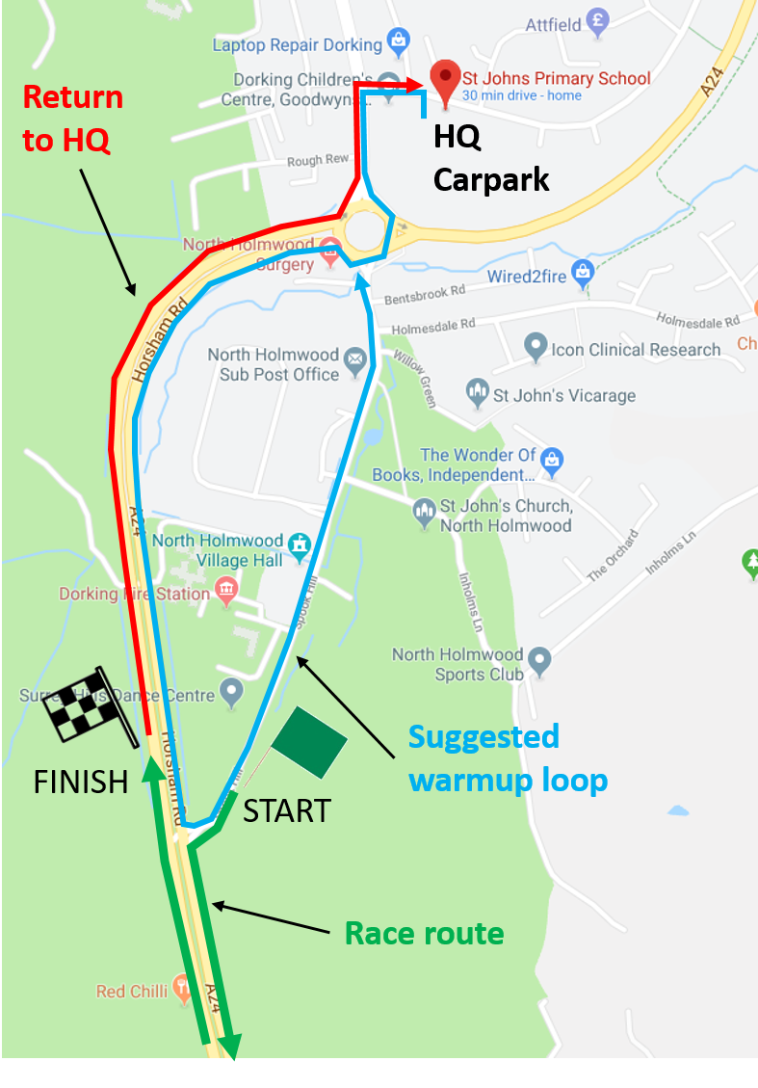

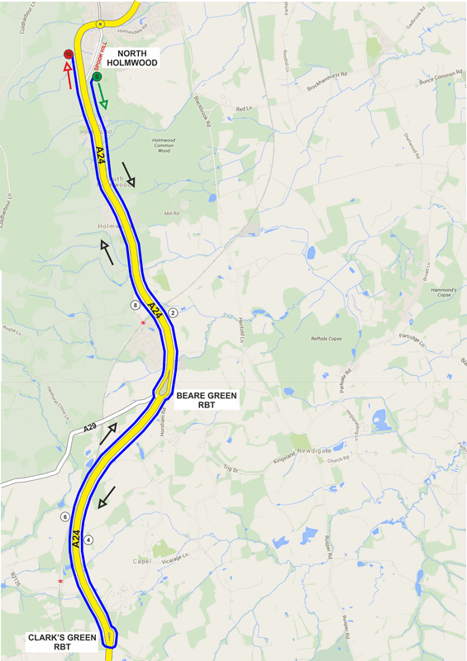
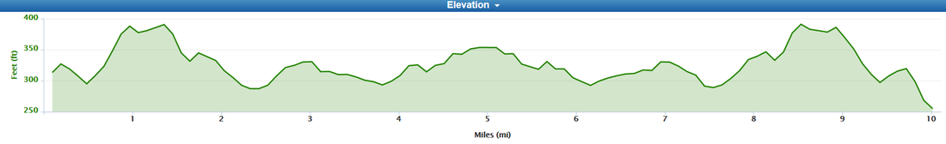

NUMBERS MUST BE FIXED BELOW WAIST

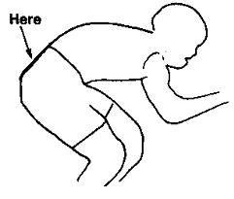

NO TIME MAY BE RECORDED IF NUMBER IS NOT CORRECTLY POSITIONED.

